WVBEAR NEBP Fill Process Checklist (No Vent-System)

  Fill Procedures

1. Lay out the tarp and weigh it down with sandbags (leave one for balloon)
2. Retrieve helium tanks and put them near the balloon.
3. At least 4 people need to line up holding the balloon with cotton gloves (palms facing up never grab or pinch) Figure 1
4. PVC attachment goes into the balloon.
5. Loosely zip tie near the ridge in the PVC then loop another zip tie through the first one then pulls the first one very tight. This is called a daisy chain. (We will have 2 ridges) Figure 2
6. Crack the helium tank for 1-2 seconds.
7. Using an adjustable wrench, attach one end of the regulator to the helium tank then attach the other end to the fill tube using lubricant if necessary and add the clip.
8. Open the tank all the way (careful not to take off the nob) then open the regulator to about half of the highest possible pressure read from the pressure meter on the regulator.
9. More people might need to be called over depending on the windiness.
10. Tether the balloon to the extra sandbag by attaching two linked carabiners to a line that attaches to the sandbag (can also use a water jug) (should be at least 55 lbs.) Figure 3
11. We will still have someone watching the balloon to ensure the zip tie attaching the balloon to the fill line is not slipping.
12. Measure the lift by attaching the fishing scale to the second carabiner and pulling down on the balloon. (The mass of the fill tube and carabiners will be known beforehand, so it is subtracted from the lift) Figure 4
13. Once the balloon reaches its desired lift (5.5 m/s), the fill is complete.

Tie Off Procedures

1. Tightly zip-tie the portion of the balloon right above the PVC Figure 5
2. Someone grabs the balloon above the previous zip-tie but still on the thick part of the latex.
3. Cut the zip tie that was holding the PVC attachment using the wire cutters (cut the zip tie on the head) Figure 5
4. About an inch below the remaining zip tie create 2 daisy chains like the first one
5. Fold the bottom of the neck up so the double daisy chain is at the bottom of the balloon then zip tie this fold together using two zip ties (we may switch to a triple fold). The neck opening should fold back over the zip ties Figure 6 | Figure 7
6. Double-check all zip ties and have one person try to hold the balloon from the daisy chains while someone still holds the neck itself.
7. Using the wire cutters, cut the ends of the zip ties off about a centimeter from the heads. Do not cut them too close, or else they may slip out when pulled.
8. Wrap zip ties and neck in duct tape Figure 8
9. If the flight string is not ready, you can tether the balloon back down so nobody must hold it. If the flight string is ready, then tie the flight string to the bottom daisy chain and prepare for launch.

Figures



Figure 1

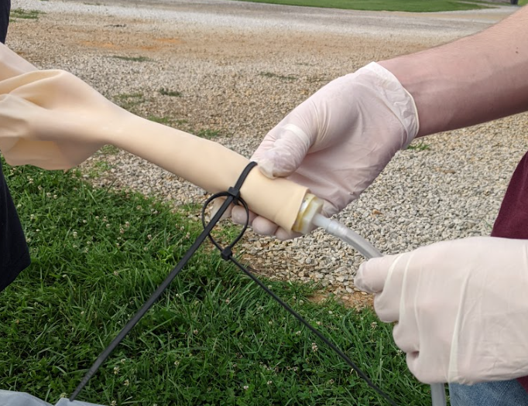

Figure 2

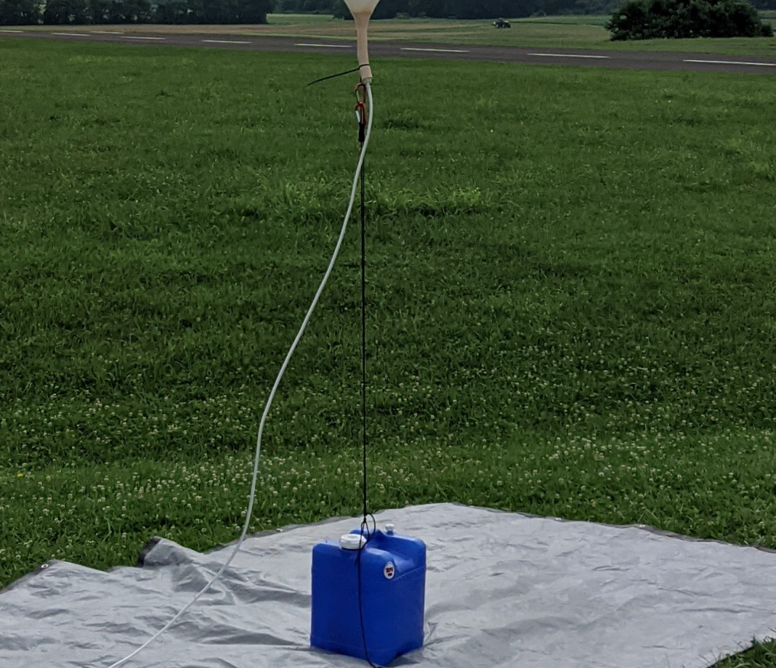

Figure 3

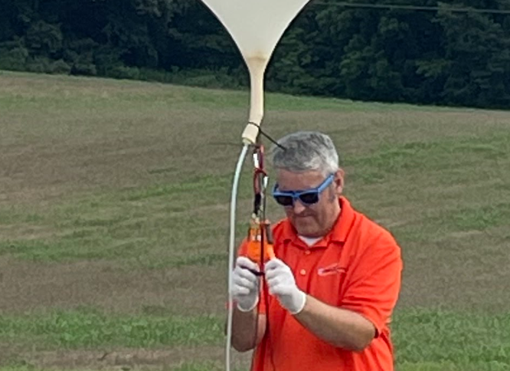

Figure 4

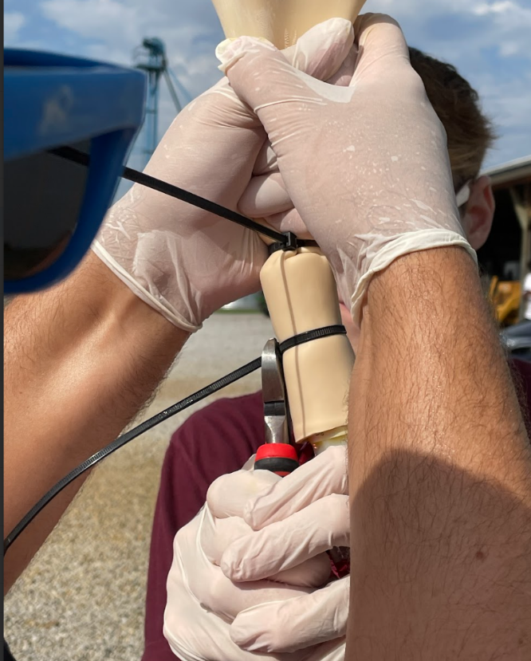

Figure 5

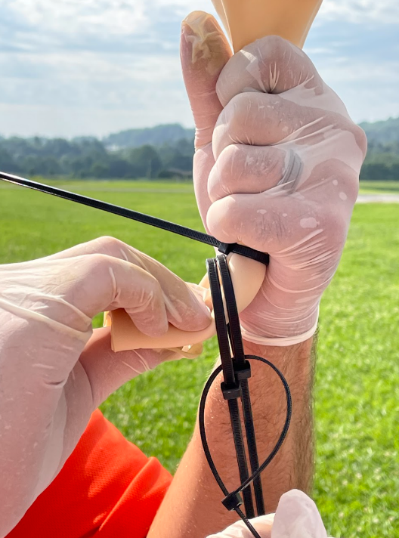

Figure 6

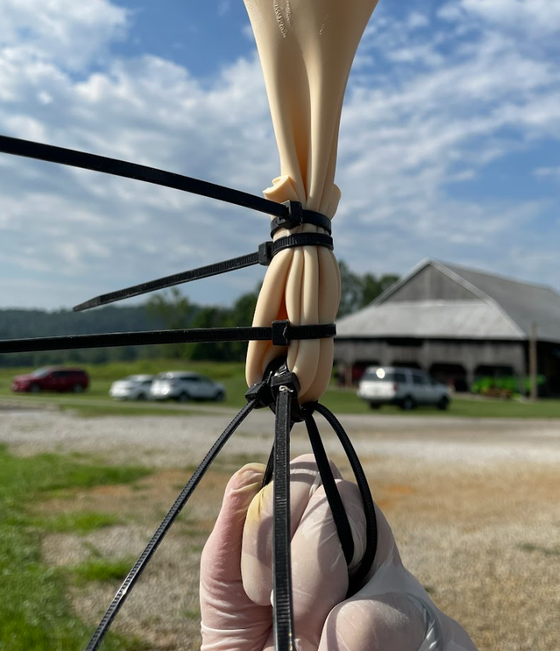

Figure 7

